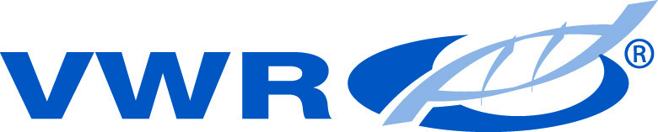
VWR International PBI S.r.l.
Via San Giusto 85
20153 Milano (MI)
Telephone: 02-3320311/02-487791 Internet: www.vwr.com

DECONTAMINATION STATEMENT

Further to the protection of our employees and representatives under EU Council Directive 89/391/EEC of 12 June 1989 and Council Directive 91/383/EEC of 25 June 1991, it is essential that all apparatus and/or components that VWR accept to perform work on are free of biological, chemical and/or radioactive contamination.
We are only able to accept apparatus and/or components that are:
• Adequately CLEANED and DECONTAMINATED.
• Provided with this decontamination statement, filled in and signed by an authorized person.
We appreciate your cooperation to guarantee a safe and risk-free workplace.

CUSTOMER :  DEPARTMENT:  COUNTRY: | Please specify your company prefered contact:  TELEPHONE NUMBER:  FAX NUMBER:  E-MAIL ADDRESS:
Please specify Package or Instrument(s) or Ordernumber for which this decontamination statement is issued. | :

Apparatus has been used in / been in contact with:  (Please specify here the material/s or state here that the apparatus has not been contaminated) | Biohazard lab  Class 1  Class 2  Class 3  Class 4 | Biohazard:  Blood  Body fluid  Pathological specimen | Chemicals which are hazardous to health | Biodegradable materials that could become hazardous to health | Radioactive substance | No contact with hazard-ous materials of any kind
I declare that the above information is complete and correct. The apparatus and/or components are adequately cleaned and decontaminated. The apparatus and/or components are free of biological, chemical and/or radioactive hazards and are safe to be handled, unpacked, examined and worked upon by VWR’s employee’s and representatives. In the event service can't take place because apparatus and/or components are not free of contamination, costs for return of the apparatus and/or components will be charged to the customer.

Name authorized person (supplier): | Function: | Signature: | Date:

